**FORM A1**

# STUDENT PLAGIARISM DISCLAIMER FORM

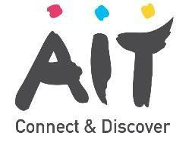

## PLAGIARISM DISCLAIMER

STUDENT NAME: Taha Aflouk

STUDENT NUMBER: A00300601

PROGRAMME: Mobile Apps & Connected Devices

YEAR: 2

MODULE: Mobile Apps

LECTURER: Mary Pidgeon

ASSIGNMENT TITLE: Sense Hat Application

DUE DATE: 03/11/22

DATE SUBMITTED: 11/03/22

ADDITIONAL INFORMATION:

I understand that plagiarism is a serious academic offence, and that AIT deals with it according to the AIT Policy on Plagiarism.

I have read and understand the AIT Policy on Plagiarism and I agree to the requirements set out therein in relation to plagiarism and referencing. I confirm that I have referenced and acknowledged properly all sources used in preparation of this assignment. I understand that if I plagiarise, or if I assist others in doing so, that I will be subject to investigation as outlined in the AIT Policy on Plagiarism.

I understand and agree that plagiarism detection software may be used on my assignment. I declare that, except where appropriately referenced, this assignment is entirely my own work based on my personal study/or research. I further declare that I have not engaged the services of another to either assist in, or complete this assignment.

## Signed:

**Dated: 01/11/22**